Name:

UTD FINAL EXAM

MIS 6311-501 Cyber Security Fundamentals

*** PLEASE READ AND FOLLOW INSTRUCTIONS CAREFULLY ***

ANSWER A TOTAL OF 25 QUESTIONS BELOW.
ANSWER 10 QUESTIONS FROM THE 1ST SECTION.
ANSWER 15 QUESTIONS FROM THE 2ND SECTION.
THE FINAL EXAM COVERS 30% OF YOUR FINAL GRADE.
- This is open book. You may use any source as long as you cite the source.
- You may use the materials from the class, Internet, or other sources.
- Cite your source in simple format – (e.g. “http://...”, “Class slides”, etc.)
- Please write your answers directly inline inside this word document.
- Should you find any questions that are the same in the 1st and 2nd section, then you are welcome to capitalize on my error.
EMAIL EXAM TO: cmd140430@utdallas.edu
*** IMPORTANT NOTE ON EXAM INTEGRITY ***
Please do not share this exam with other students. Your choice to preserve the integrity of this exam helps ensure others get the opportunity to have the same testing experience.

This FINAL Exam Covers the entire course.
- GRC and IT Controls; Building the Security Program
- Access Control
- Telecommunications and Network Security
- Information Security Governance and Risk Management
- Software Development Security
- Cryptography
- Security Architecture and Design
- Operations Security
- Business Continuity and Disaster Recovery Planning
- Legal, Regulations, Investigations and Compliance
- Physical (Environmental) Security
- Emerging Technologies
- The Reality of Soft Skills
- Compromising Security Programs
About the Final Exam:
The purpose of this exam is to give you real life questions and business problems encountered every day during the professional application of information security and risk management to world-class organizations.
The learning process does not stop after the lectures. Given the foundational base of the course information, I encourage you to spend the next few hours pulling this information together as you answer these questions.
Your achievable and realistic objective in this course is to learn enough to remember some details, and look the rest up. This is how I exercise my job every day, and why I feel this exam is the most appropriate means for testing your knowledge. Good luck!

What to do if you find a question that covers material you haven’t seen before?
1. Research and provide a reasonable answer… or…
2. Skip and answer another question. There are plenty to choose from.

SECTION A: answer 10 questions from this section.
- Five words are missing from the picture below. What are they? Hint: this diagram in another form was shown at the end of every class.
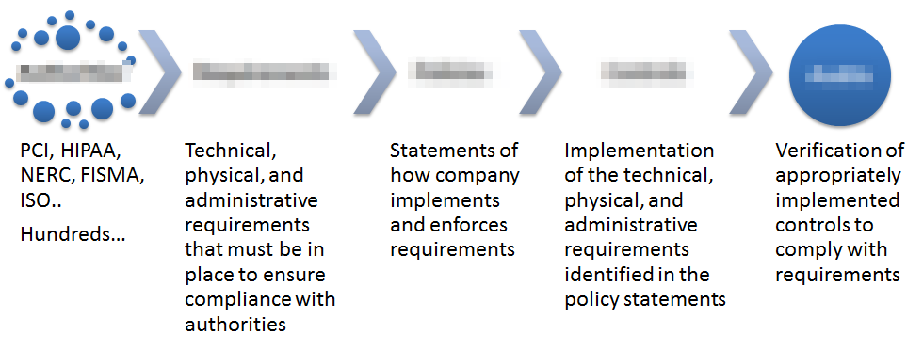

Authorities -> Requirements -> Policies -> Controls -> Audits
- What are the forms of multi-factor authentication (hint.. there are three)
- What is the purpose of an IPS?
- What does AAA stand for? Define each with an example.
- What are the components of the CIA Triad? Define them.
- Security programs have goals. Explain 3 types of goals.
- Who is ultimately responsible for an organizations security? There could be more than one answer to this question, depending on how it is that you defend your answer.
- What is the difference between a vulnerability, threat, and exposure?
- What are the goals of (specifically…) Risk ANALYSIS. (Hint. Answer has five bullets.)
- What is SLE? What is the formula for SLE? Please spell everything out…
- Explain an example of a Qualitative Risk method.
- What is the difference between the security policy, standard, and baseline?
- What is the difference between a data owner and data custodian?
- What is the importance of individual separation of duties?
- Why is penetration testing important?
- What is a protocol and what is data encapsulation?
- What is the difference between TCP and UDP connections?
- Traditionally, name 5 differences between circuit switching and packet switching as discussed in the class.
- Using descriptions discussed in the class, describe the differences between layers 2 and 3 of the OSI model.
- What is the difference between multi-home firewalls and screened subnets?
- The class kicked off with a discussion from a presentation I delivered at the RSA Security Conference in London. We discussed the PCVMR Cycle. What does this stand for? What are the key objectives for the components that make up the PCVMR cycle?
- Provide three examples each for Technical, Physical, and Administrative controls.
- We mentioned common technical controls in relation to a solutions crosswalk. The first example was in a portion of the presentation I presented to the RSA conference in London and had 18 specific controls. Why do we care about this? What is the significance of having this control set addressed?
- We do not spend a lot of time on the difference between ISO27001, and iso-27,002. Either in the slides or online, find the difference and explain it.
- What is the result from assessing risk? Simple question. Many answers. The most concise answer I’ve seen is from the atsec ISO 27,000 program overview that we covered in session 3.
- It doesn’t get any easier than this. Information is beautiful. Using any measure you would like, name and quantify 3 large breaches in the last 10 years. Because of how the question is worded, there are many answers.
- Identify 5 real-world problems with access controls. Why is it difficult?
- Define access controls.
- What is the crossover error rate? Do not overthink this one.
- Describe what each of the following measure:
  - Fingerprint –
  - Hand topology –
  - Hand geometry –
  - Retina Scan –
  - Iris scan –
- How does an asynchronous one time password work?
- What is the difference between mandatory and discretionary access controls? This answer can be as simple or complicated as you would like.. You can use text or a picture.
- Find a description of the 7 layers of the OSI model. Explain the primary difference between transport and network layers.
- What is the difference between liability, connection, and packet sequencing between TCP and UDP?
- What is a network socket?
- What is the difference between background noise and attenuation?
- What is the difference between CSMA/CD and CSMA/CA?
- What is the difference between an application level proxy, circuit level proxy, and kernel proxy?
- Find from any source and describe 3 different forms of Bluetooth attacks.
- What is the purpose of defense in depth?
- What is the difference between risk and a control?
- What are 2 other names for “control”?
- What are 5 differences between quantitative and qualitative risk management?
- Two specific sites covered key considerations for the “functionality and effectiveness of countermeasures”. Identify what you consider to be the most important characteristic and explain why. There are multiple answers. You simply need to defend yours.
- If you have effectively enforced separation of duties inside an organization, then to subvert controls you may have to have collusion. Describe collusion.
- What is the difference between verification and validation?

SECTION B: answer 15 questions from this section.

- MUST ANSWER: Explain the relationship between the 5 elements below. We did this multiple ways, and there are several acceptable answers. I want to know that you can think through each of the following.
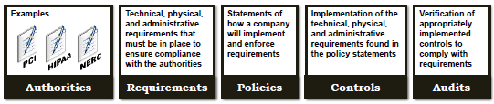
- MUST ANSWER: Explain what we reinforced by showing the Porter Value Chain at the end of every class. You can either explain in your own words, or use the 3 simple statements.
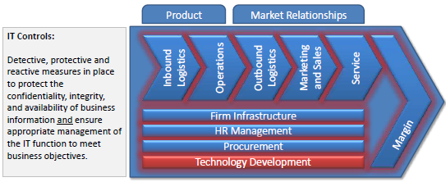
- What are the steps in the Lockheed Martin Intrusion Kill Chain?
- Choose one of the steps of the Intrusion Kill Chain and explain the courses of action matrix.
- Explain 2 differences between block and stream ciphers.
- Define Method and Key.
- Give an example of the symmetric, asymmetric, and digest algorithms.
- What are the Symmetric Key Pros & Cons?
- What are the Asymmetric Key Pros & Cons?
- What is the difference between cipher text and plain text?
- If a message is encrypted/encoded/enciphered with an Bob’s public key, what key is required to decrypt/decode/decipher the message?
- What is a One-Time-Pad? --- OR --- How is an email digitally signed to ensure the integrity of the contents?
- What are the 7 steps, or phases, in Business Continuity Planning?
- What is the difference between a checklist test, structured walk-through, and simulation test?
- What is the difference between a parallel test and full interruption test?
- What is the difference between a hot site, warm site, and cold site?
- Explain the concept of redundant sites.
- What is the difference between RTO and RPO?
- Provide examples of common MTD classifications.
- Explain the difference between patents, copyrights, trade secrets, and trademarks.
- What is the difference between criminal and civil law?
- What are your actions if you think that you have a criminal case?
- Usually during investigations there are multiple decision points. Explain 3.
- New vulnerabilities practical application: We discussed Microsoft’s Kerberos flaw that was recently released. What is the flaw, and why is it bad?
- Security Architecture and Design covered the concept of protection rings. Each inner ring is more privileged and provides services on behalf of the outer rings. The Number of rings an OS can have is dependent on the type of processor that it runs on. Give an example of what each of the four rings below might represent.
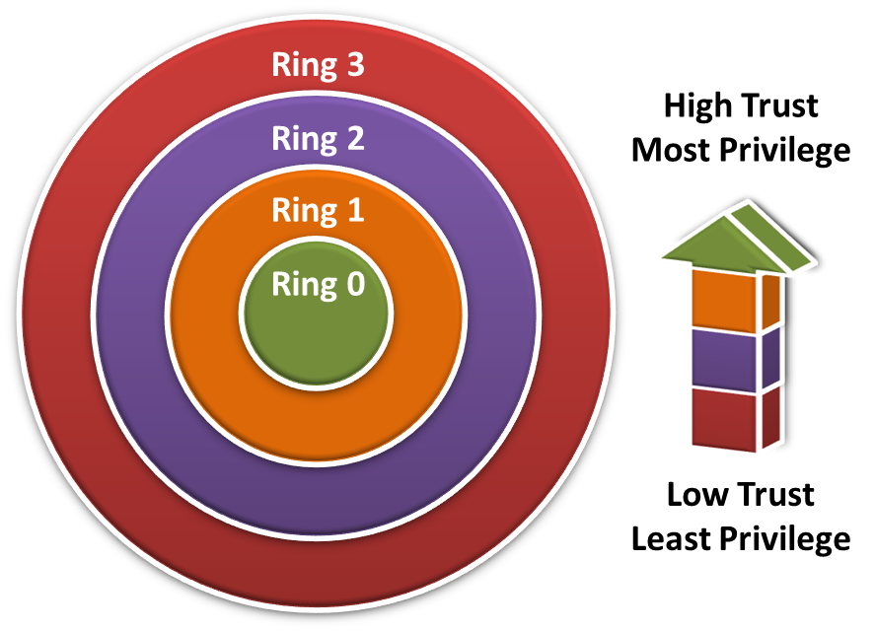
- What is the Trusted Computing Base (TCB)?
- Notice that the Reference Monitor is an abstract or conceptual idea. It is used to discuss the interaction between the five components below. Fill in the blanks below using the words in the blue boxes. The first one is done for you.
  - The ultimate goal is to define and control using a repository of subject and object security attributes (__ authorization database __)
  - the access of active entities, users, and processes (_______)
  - to files, directories, data or services (__________)
  - based on situational context (__________)
  - and record security related events (__________)
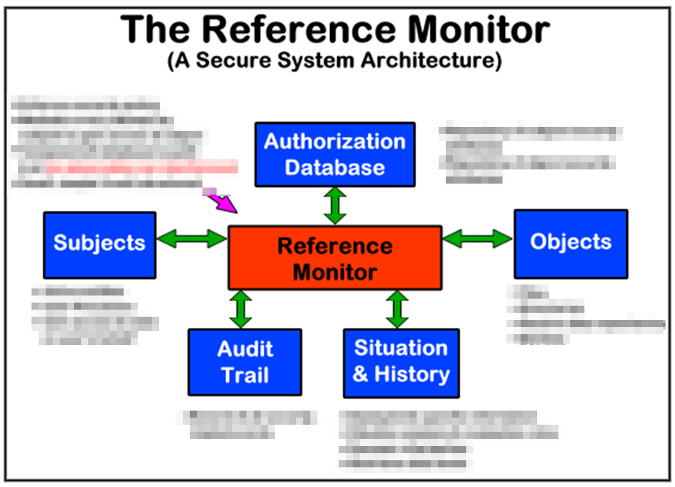
- The Security Kernel is the hardware, software and firmware that fall within the trusted computing base and implements and enforces the Reference Monitor concept. Which of the following is correct?
  - (True/False) The Security Kernel is typically very large because of the complexity involved in managing the Reference Monitor.
  - (True/False) The Security Kernel is typically very small because it must be tested and verified comprehensively.
- Which security model is represented below?
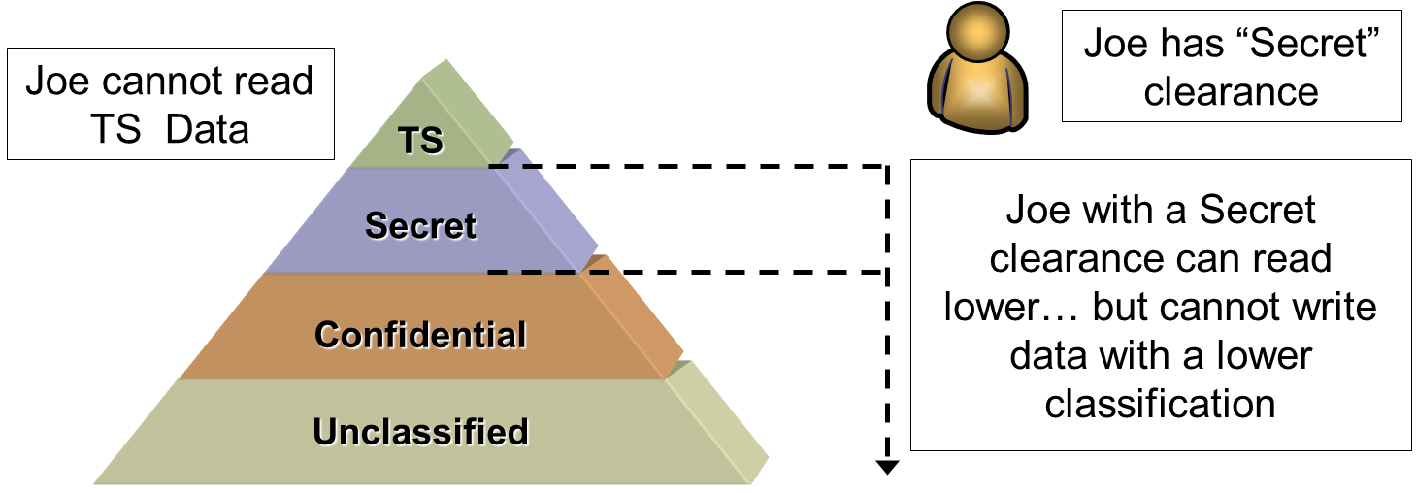
- Which security model is represented below?
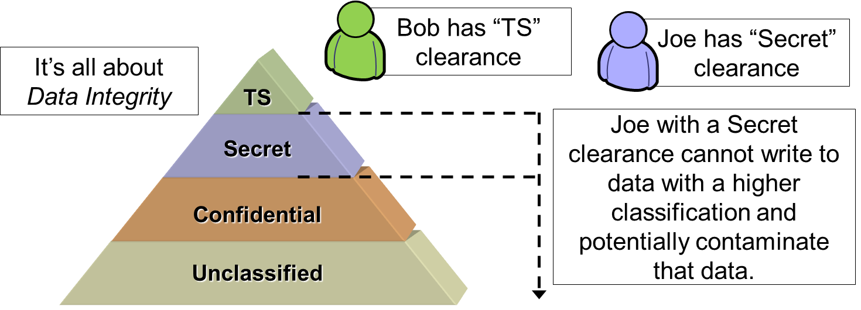
- What is this and what does it do?
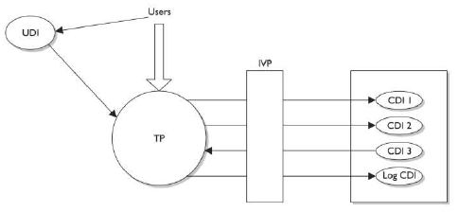
- Find a chart or description discussing the differences between dedicated security, system high security, compartmented security, and multilevel security modes.
- Describe the difference between RAID 0, RAID 1, and RAID 5.
- What is CPTED stand for and how does it reduce crime?
- CPTED includes some very cool ideas such as natural access control and natural surveillance. What are some examples of territorial reinforcement?
- What are some areas to consider when designing a physical security program?
- What is a man trap?
- Name and describe 5 example environmental issues.
- What is the difference between classes A, B, C, and D fires?
- Name and describe 3 example physical security IDS.
- When discussing automatic fire suppression, there were different types of systems covered. What is the difference between wet pipe, dry pipe, and pre-action?
- Explain the differences between grade 1, grade 2, and grade 3 physical locks.
- What is the difference between focal length and depth of field for physical security surveillance cameras?
- Name 10 general actions that you would take for systems hardening.
- Which RAID level does this represent?
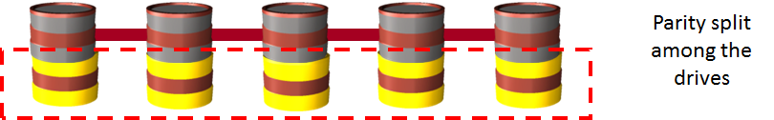
- What 3 backup types are represented by the below?
